Field Group Project Final Submission

by

Berthel Whyte, Johnoy Mendez, Hakeem Gooden & Raheem Robinson

An assignment submitted in partial fulfillment of the requirements

for the course CPTR293 Field Group

Instructor: Mr. Renaud Chin

Date: December 2, 2019

Department of Computer and Information Sciences

Northern Caribbean University

**Preface**

It is a great experience for the I-Quad team to develop a system that will help in improving the medical industry across the island of Jamaica. Our team of four members were awarded the honor of completing a project which would improve patients means of setting appointments to doctor’s offices. Upon receiving this opportunity, we went out to determine what way we can develop a Medical appointment system to benefit patients, receptionists and doctors. In addition, we needed to find a way to make this medical appointment system more unique and different than that which already exists. After doing our research, we found out that what was missing from doctor’s offices across Jamaica was an efficient way for users to schedule appointments. We the I-Quad team decided to develop a web application which will be able to: make the process of setting appointments easier, present appointment information to potential patients and provide the ability to quickly find and verify patient appointments.

**Table of Contents**

Executive Summary 4

Introduction 5

Overall description 6-7

System Features 8-9

Other Nonfunctional Requirements 10

Technical Aspects 11-15

Known Errors 16

Appendix

**Executive Summary**

I-Quad Medical Appointment system is a web application based in Jamaica that can be used on all platforms. We give doctors office the ability to provide an appointment system that is easy to use and enable patients to make appointments anywhere at any time.

The problem that the team came across is that receptionist have to manually search through a number of cabinets or pages to verify appointments. Users sometimes have to walk in to the office to set appointments which is an inefficient and time-consuming way of doing things. The purpose of the project is to minimize the hassle of dealing with appointments for both the potential patients, doctors and other corresponding personnel. From the problem of manually recording the patient’s information, to having to walk in to the facility to set an appointment, all this will be made easier with the application. We the I-Quad team decided to develop a web application which will be able to make the process of setting appointments easier for users. This will be accomplished by having a simple and easy user interface for the users, where they will be able to see appointment days and time for a particular doctor (or organization) and select the one which best suits their needs. Doctors will also be able to present appointment information to potential patients through the application. Receptionists will be able to quickly find and verify patient appointments when they get into office by using the application to search, find and verify appointment information.

**Introduction**

**1.1 Purpose**

We the developers at I-Quad saw the need to implement this system to reduce amend the issues that surround the whole process of setting appointments. The purpose of this system is to reduce the likelihood of data recording errors, and allow for flexible appointment scheduling capabilities, as this system can be accessed at any time of day, and not just within office hours.

**1.2 Intended Audience and Reading Suggestions**

The intended audience comprises of doctors, patients, and receptionists.

**1.3 Product Scope**

Our application allows the patients to set appointments, receptionists to verify appointments much faster and doctors to present appointment information to patients. Information about the type of doctor and Patient reservation can retrieved from a database when needed by administrators.

**1.4 References**

(Sagenda Medical Appointment Software)

<https://www.sagenda.com/increase-business-productivity/medical-appointment-scheduling-software/>

<https://www.sagenda.net/?_ga=2.267102792.774742702.1573963590-2123928308.1573963590>

**Overall description**

**2.1 Product Perspective**

Our product is a web-based application system that allows users to choose available time slots, provide reason for visit and choose the type of doctor needed when setting an appointment. The application is responsible for receiving appointment submitted by the patient and viewed by the receptionist for verification before seeing the doctor. It also allows the doctor to change the time schedule of patient based on his/her time schedule for that particular day.

**2.2 Product Functions**

Patients will be able to set an appointment with an available doctor by selecting the day and time that best suits their needs.

Doctors will be able to post the schedule of when they will be available so potential patients are able to select those time.

Potential patients will be able to find accurate, relevant and reliable information about their symptoms, causes and treatments through our application.

**2.3 Operating Environment**

The I-Quad Medical Appointment System will have a global operating environment. A user will be able to access the application and set appointments from wherever they are.

**2.4 Design and Implementation Constraints**

* The system will be developed using the Microsoft Asp.Net platform
* Time given to complete project is approximately 2 months
* We are unable to complete the search engine that would make our system unique in time for submission.

**2.5 Assumptions and dependencies**

Factors affecting the requirements specified would be:

* Users will need to register on the system before they can use its features
* Users can’t access the Web Application without internet access

**2.6 Allocation of Requirements**

Detailed requirements with respect to the economic front-end, that is, the exact costing and pricing policy that will be used to charge users for using the application will be specified at a later date when the application is further developed and ready to be released to the general public.

**System Features**

**3.x System Feature**

The application will allow:

1. Input of data - Setting Appointments

2. Storage of data - Store Patients Information and appointments

3. Retrieval and display of data – Doctors, Patients, Administrators and Receptionists can view appointments and make the necessary feedback or changes.

**3.x.1 Description and Priority**

The requirements for the features describe how the application will collect, store and retrieve data. The users are currently expected to use any computer or mobile device of their choice to communicate with the Web Application.

**3.x.2 Stimulus/Response Sequences & Information flows**

Stimulus: A patient wants to set an appointment to a medical doctor for whatever purpose they might have.

Response: The Application allows the patient to choose time slots, state their purpose of visit, choose doctor then set an appointment.

Stimulus: Doctors probably may become unavailable for a certain time on a particular day.

Response: The system allows Doctors to conveniently change and update their schedule based on their needs.

**3.x.3 Functional Requirements**

The system should:

* Set Patients appointments
* Allow Receptionist and Doctor to view patients who have set appointments
* Send alerts to Patients when time selected is already reserved by someone else
* Enable patients to view and choose Doctors suited for their issue

**Other Nonfunctional Requirements**

**4.1 Performance requirements**

The application should have a quick response time.

Users must be able to access the application at any time where there is internet access.

Application should be error and issue free.

**4.2 Business Rules**

Receptionist will be able to view and verify patients’ appointments.

Patients appointments should not clash with the same time.

Doctors should be able to view all patients appointed to them and change time slots if necessary.

**4.3 User Documentation**

A user Manual is provided for all users.

**4.4 Other Requirements**

The system currently requires each user to register on the system before they can access certain features or set appointments.

**Technical Aspects**

**Overall System Architecture Diagram**

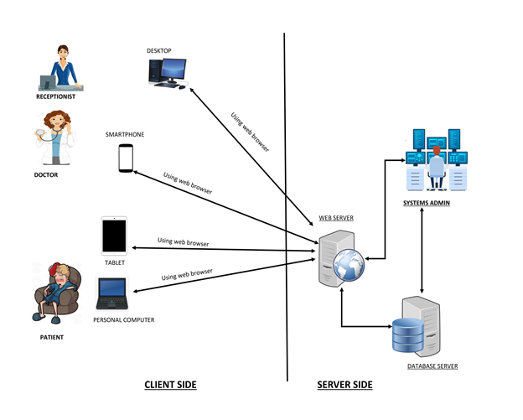

**Data Dictionary**

|  |  |  |  |  |  |  |  |  |
| --- | --- | --- | --- | --- | --- | --- | --- | --- |
| Field Name | **Data Type** | **Data Format** | | **Field Size** | | **Description** | | **Example** |
| **User** | | | | | | | | |
| User_ID | int | |  | |  | | Unique number assigned to all User | 123456 |
| Fname | varchar | |  | | 45 | | First Name for User | Kurt |
| Lname | varchar | |  | | 45 | | Last Name for User | Weller |
| Age | int | |  | | 3 | | User’s age | 25 |
| Phone_Number | varchar | |  | | 20 | | User’s phone number | 18765422789 |
| Gender | varchar | |  | | 1 | | Gender of the user | F or M |
| District/Town | varchar | |  | | 30 | | Address of the User | Negril |
| Parish | varchar | |  | | 30 | | Parish in which User from | Westmoreland |
| Street | varchar | |  | | 30 | | Street Address of user | Matches Lane |
| Appointment | | | | | | | | |
| Appointment Number | int | |  | | 5 | | Uniquely identifies each appointment made | 12345 |
| Patient_ID | int | |  | | 5 | | Uniquely identifies each Patient | 12345 |
| Doctor_ID | int | |  | | 5 | | Uniquely identifies each Doctor | 12345 |
| Purpose_Of_Visit | text | |  | |  | | Detail description of the purpose of visit | To get a regular check-up |
| Date | Date | | DD/MM/YYYY | | 10 | | Selection of Date for the particular appointment | 25/04/2019 |
| Start_Time | time | | Hh:mm | | 5 | | Time of an appointment | 10:00 |
| End_Time | time | | Hh:mm | | 5 | | Ending time of an appointment | 11:30 |
| User Type | | | | | | | | |
| User_Type_ID | int | |  | | 5 | | Uniquely identifies user type | 12345 |
| Name | varchar | |  | | 20 | | Specifies who using the system | Patient/Doctor |
| Description | text | |  | |  | | Detail Description |  |
| Specialties | | | | | | | | |
| SpecialtyID | int | |  | | 5 | | Uniquely identifies specialty | 54321 |
| Name | varchar | |  | | 20 | | Name of the Doctor’s specialty | Optician |
| Descript | text | |  | |  | | Description of the Specialty | Eye specialist |
| Doctor Specialty | | | | | | | | |
| User_ID | int | |  | | 6 | | Unique number assigned to all User | 123456 |
| SpecialtyID | int | |  | | 5 | | Uniquely identifies specialty | 54321 |

**Use Case**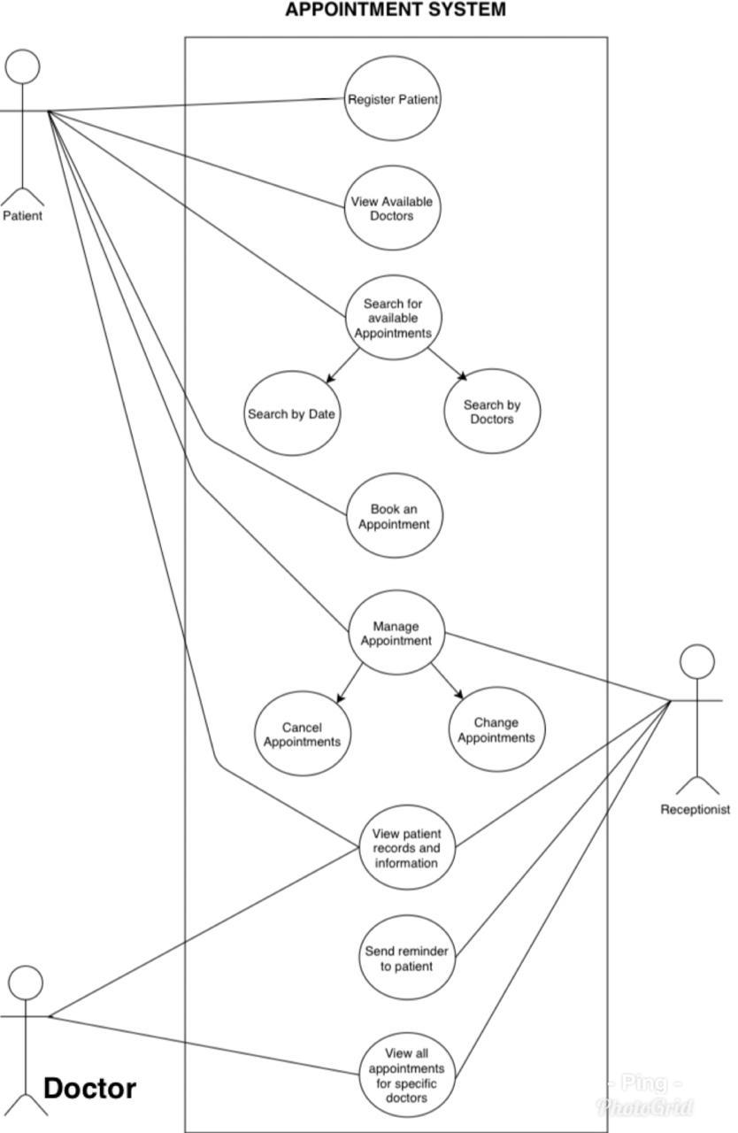

**Entity Relationship Diagram**

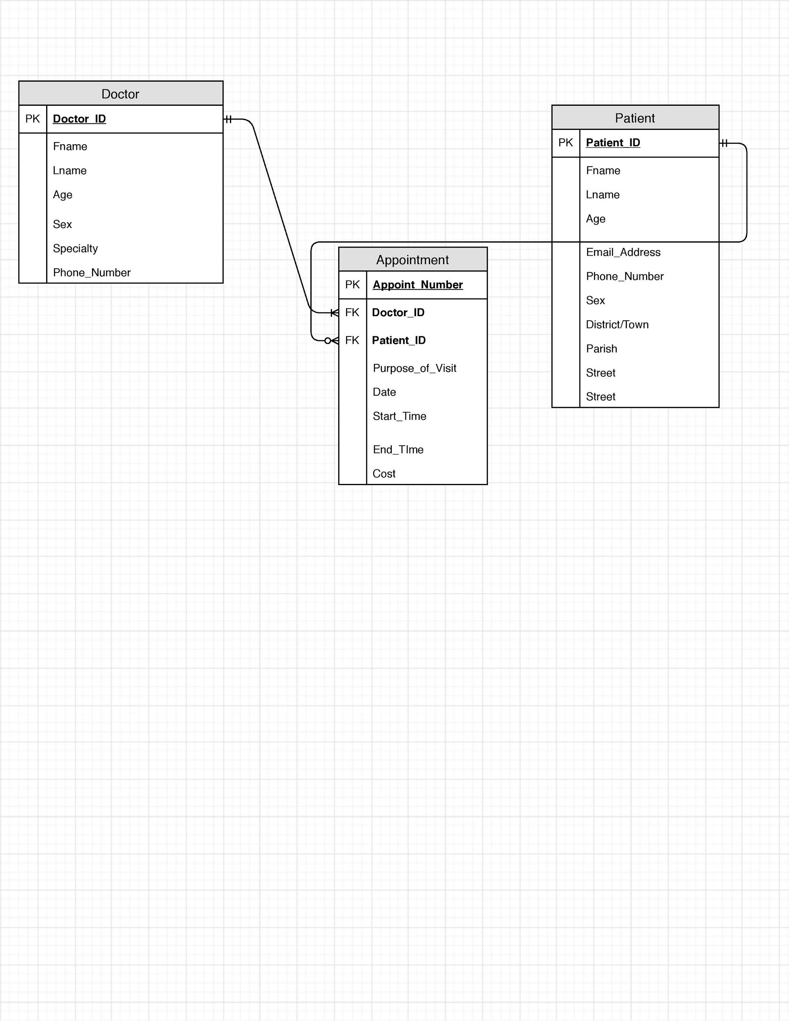

**Data Flow Diagrams**



**List of and explanation of all known errors in the program**

* Multiple users are currently able to set appointments on the same day and time. This will cause appointment conflicts and should not be so.
* Users are also able to set an appointment for a past date. This is an error because this is not logical and should be fixed.

**Appendix**

**Appendix A: Glossary**

**Admin**: An Administrator, a person responsible for carrying out the administration of a business or organization.

**Application**: An application, or application program, is a software program that runs on your computer.

**Appointment**: an arrangement to meet someone at a particular time and place.

**ASP.NET:** ASP.NET is an open-source server-side web application framework designed for web development to produce dynamic web pages developed by Microsoft to allow programmers to build dynamic web sites, applications and services.

**Database:** A database is an organized collection of data, generally stored and accessed electronically from a computer system. Where databases are more complex they are often developed using formal design and modeling techniques.

**Doctor:** is a professional who practices medicine, which is concerned with promoting, maintaining, or restoring health through the study, diagnosis, prognosis and treatment of disease, injury, and other physical and mental impairments.

**Medical:** an examination to assess a person's state of physical health or fitness.

**Patient:** a person receiving or registered to receive medical treatment.

**Receptionist:** A receptionist (sometimes referred to as an administrative assistant) is someone who performs various administrative tasks, including answering telephones and giving information to the public and customers. Receptionists are often the first employee that the public or customer has contact with.

**Appendix D**

**The Self-Assessment form (I have the form)**

**SELF ASSESSMENT FORM**

Project Title: I-Quad Medical Appointment System

Names of Group Members: Johnoy Mendez, Hakeem Gooden, Raheem Robinson & Berthel Whyte

|  |  |  |  |
| --- | --- | --- | --- |
| **Category** | **Score** | **Max** |  |
|  | ‘ |  |  |
| Project Proposal | 8 | 10 |  |
|  |  |  |  |
| Systems Documentation | 23 | 25 |  |
|  |  |  |  |
| User’s Manual | 5 | 05 |  |
|  |  |  |  |
| Coding and Execution |  |  |  |
|  |  |  |  |
| Design |  | 10 |  |
| *(user interface, organization, layout, user friendliness)* | 10 |  |
|  |  |  |
|  |  |  |  |
| Content | 4 | 05 |  |
|  |  |  |  |
| Functionality |  | 20 |  |
| *(working modules, functions, reports)* | 16 |  |
|  |  |  |
|  |  |  |  |
| Complexity | 3 | 05 |  |
|  |  |  |  |
| Team Cohesiveness/Togetherness | 10 | 10 |  |
|  |  |  |  |
| Project Presentation | 8 | 10 |  |
|  |  |  |  |
| **TOTAL:** | 87 | **100** |  |
|  |  |  |  |

**TEAM MEMBERS’ ASSESSMENT**

**Project Title: I-Quad Medical Appointment System**

**Team Leader: Johnoy Mendez**

**Group Leader’s role(s) and responsibilities:**

|  |  |  |  |  |  |  |
| --- | --- | --- | --- | --- | --- | --- |
|  | **Group** | **Role(s)** | **Tasks Done** | |  | **Team** |
|  | **Member’s** |  |  |  |  | **Member’s** |
|  | **Names** |  |  |  |  | **Signature** |
|  |  |  |  |  |  |  |
|  | Johnoy Mendez | Coder | Coding Backend and preparing milestones |  |  | J.Mendez |
|  | Hakeem Gooden | Coder | Coding Backend and creating user manual |  |  | H.Gooden |
|  | Raheem Robinson | Designer | Coding Frontend and drawing system diagrams |  |  | R.Robinson |
|  | Berthel Whyte | Designer / Documenter | Coding frontend and prepare documents |  |  | BWhyte |
|  | **Team Leader’s Signature: J.Mendez** | |  | **Date:** | 12/02/19 |  |
|  |  | |  |  |  | |